Inventory & Stock Analysis Report
Dataset: Zepto Inventory Data

Step 1: Dataset cleaning in this process I check is that have any duplicates value.
Step 2: Second process of cleaning is to check blank space in dataset for I use count Blank (=COUNTBLANK ()).
Step 3: After appear formular I get value of blank and to delete that I use filter in every column head.
Step 4: Check every column by appear filter and delete every blank rows.
Step 5: Read that and understand main column that I need to solve the “Problem Statements”.
Step 6: I note that their quantity of sales and available quantity column was present in dataset. To calculate Sale ratio, I div available quantity by quantity of sales (=available quantity(h2)/ quantity of sales(I2))
Step 7: After calculate Sale ratio I create one column in which I check that products is overstock or not by (= if (sale ratio>5,” overstock”, “not”)).
Step 8: Select whole dataset and create a Pivot table to solve first problem statements
Step 9: In Pivot table I take date as filter and country in rows with Count of track as value.
Step 10: By using Pivot table data, I create a line chart.
Step 11: Select whole dataset and create a Pivot table to solve second problem statements
Step 12: In Pivot table I take city in rows with Count of track as value.
Step 13: By using Pivot table data, I create a line chart.
Step 14: Select whole dataset and create a Pivot table to solve three problem statements
Step 15: In Pivot table I take date in rows with Count of track as value.
Step 16: By using Pivot table data, I create a line chart.
1. Problem Statements
The warehouse team wants better stock control. They want to know:
- Which products are overstocked?
- Which products may go out of stock soon?
- What is the category-wise stock health?

2. About the Company
From the dataset analysis, I understand that the company operates in 10-minute delivery services.
They store products in warehouses and deliver items directly to customers homes.

3. About the Dataset
The dataset contains inventory details of products. There are 12 columns in the dataset, including Product Name, Category, MRP, Discount Percent, Available Quantity, Discounted Selling Price, Weight (in grams), Out of Stock (Yes/No), Quantity Sold, Sales Ratio and Overstock (calculated). Product Categories Include Cooking Essentials, Munchies, Fruits & Vegetables, Home & Cleaning, Chocolates, Dairy, Bread & Batter, Beverages, Health & Personal Care, Baby Care, Pan Corner, Last Minute Needs and Fish & Eggs.

Problem 1: Which products are overstocked?
By analysis I found that the Quantity of sales and available quantity Column was already data set Solving the problem I calculate Sale ratio for that I divide available quantity by quantity of sales If the sales is more than 5 that Indicate the product overstocked By this, I checked the product Is overstock or not and in predictable I select Filter over shocked prices yes and got the answer There are Open accessories and Munchies Are the highest quantity that available rolling quantity is so these two products are being overstock.
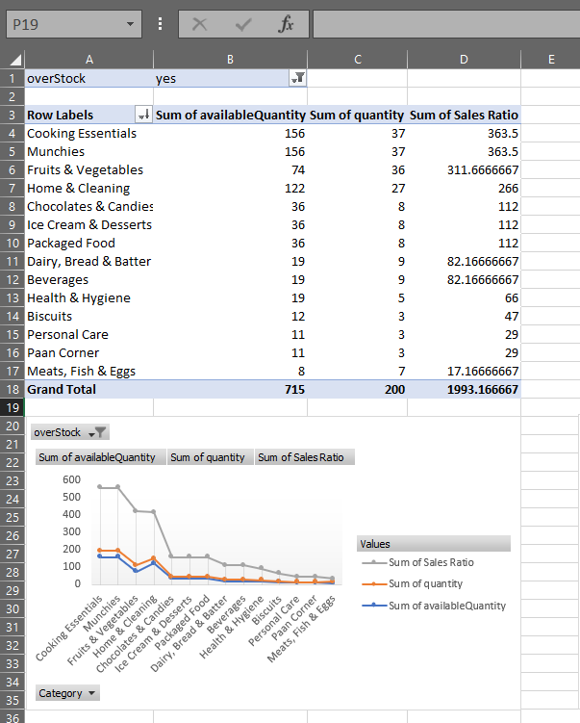

Problem 2: Which products may go out of stock?
To find this, I checked Out of Stock column which already in dataset. Products with low available quantity but high sales. Products that are likely to go out of stock soon mainly are Fruits & Vegetables, Home & Cleaning, Cooking Essentials and Munchies
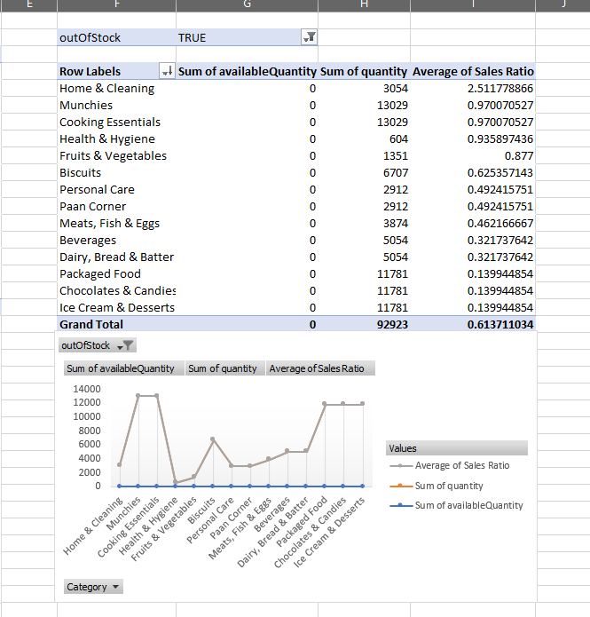

Problem 3: Category-wise Stock Health
Here I analysed stock condition category by category. I compared Total Stock with Total Sales
Stock Condition | Categories
High Stock but Low Sales | 5 categories (risk of overstock)
Low Stock with Low Sales | 7 categories
Balanced Stock & Sales | Personal Care, Pan Corner, Last Minute Needs

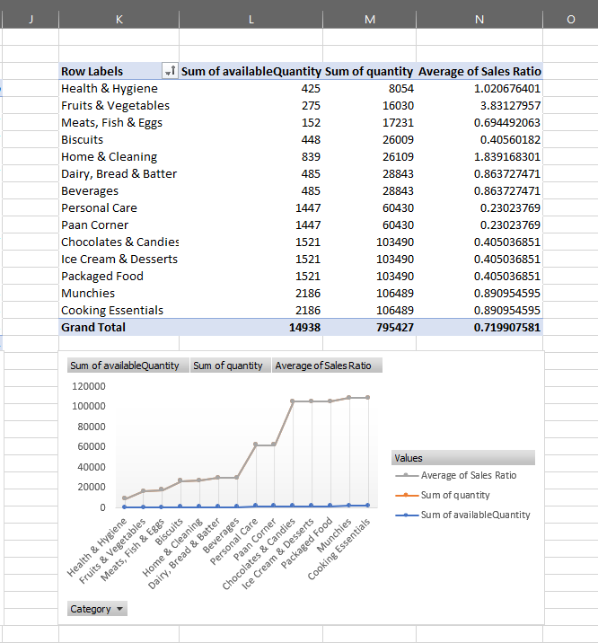
Recommendations:
- Reduce stock for slow-selling products
- Increase stock for fast-selling products
- Regularly monitor Sales Ratio to maintain stock balance

